Advanced WEB Technologies – Crypto-News
Group number 8_61776


ID | Submitters
207281874 | Elad Krauz
206131849 | Uri Ziv
318158565 | Lee Potashnik
207754946 | Tal Turgeman
208080705 | Ofir Berkovitsh

The Crypto News application is a comprehensive platform using React, Tailwind CSS, and JavaScript. The main functionality allows users to stay updated with the latest cryptocurrency news through a visually appealing and user-friendly interface. The homepage features a dynamic news carousel that displays the most recent and relevant news articles from various sources, and the user can filter by popular cryptocurrencies such as Bitcoin, Ethereum, Tether and more . Users can access detailed information about the platform and its team on the About page, while the Contact Us page facilitates user feedback with real-time form validation. The project emphasizes accessibility, usability, and responsive design, ensuring an optimal experience across various devices.

Application link:
https://crypto-news-eosin.vercel.app/
Link to GitHub repository:
https://github.com/Eladkrauz/CryptoNews.git
more than wallet link:
https://www.morethanwallet.com/app/845

Advanced WEB Technologies – Final Project
Group number 8: Elad Krauz, Uri Ziv, Lee Potashnik, Ofir Berkovitsh, Tal Turgeman
Question 1:
The system engineer is Ofir Berkovitsh.
The tasks were given to each team member:
Elad Krauz | Implementing the HTML part  Implementing the Tailwind CSS part  Researching about cryptocurrencies  React  Architecture  API
Uri Ziv | Designing the app layout ideas  Writing functional requirements  Architecture  API  Responsiveness  Preparation of a user file
Lee Potashnik | Designing the app layout ideas  Writing non-functional requirements  Filtering the NFR into classes  Architecture  API  USE CASE  Preparation of a user file
Ofir Berkovitsh | Assigning tasks to each team member  Designing the app logic ideas  Architecture  API  USE CASE  Preparation of a user file
Tal Turgeman | Implementing the JavaScript part  Researching about cryptocurrencies  Architecture  API  Responsiveness  Documentation
There was indeed coordination and correlation between the work of the team members. Elad designed the part related to HTML and CSS, while Tal designed the JavaScript part. Their work was based on plans that Ofir and Uri made (in the context of the layout of the application), on requirements that Uri and Lee wrote and on research that Elad and Tal did on cryptographic currencies.

Question 2:
Functional Requirements:
Real-Time News Aggregation: The system will fetch and display latest news articles related to cryptocurrencies.
Currency-Specific Filtering: The system will allow users to filter news based on at least five major cryptocurrencies.
Error Message for API Access Limit Reached:The system shall display an error message to the user when the number of accesses to the API has been exhausted.
Sending Email Message via "Contact Us" Form: The system shall provide users with the capability to send an email message to the support team through a "Contact Us" form.
Responsive Design for Multiple Screen Sizes: The system shall provide a responsive design that allows the application to display correctly on various screen sizes, including but not limited to desktops, tablets (e.g., iPads), and smartphones (e.g., iPhones).
Dark Mode and Light Mode Toggle: The system shall provide users with the ability to switch between dark mode and light mode at any time, regardless of the current mode.
Non-Functional Requirements:
Performance:
- Scalability: The system should handle up to 100 concurrent users without significant performance degradation.
- Response Time: The application should fetch and display news articles within 3 seconds of a request.
Usability:
User Interface: The interface should be simple and intuitive, ensuring users can easily navigate and filter news articles without prior training.
Reliability:
- Availability: The application should have an uptime of 95%, ensuring it is available to users most of the time.
- Error Handling: The application should handle errors, providing clear error messages to users.
Maintainability:
- Code Quality: The codebase should follow standard coding practices, including proper documentation and modularization.

Website architecture :
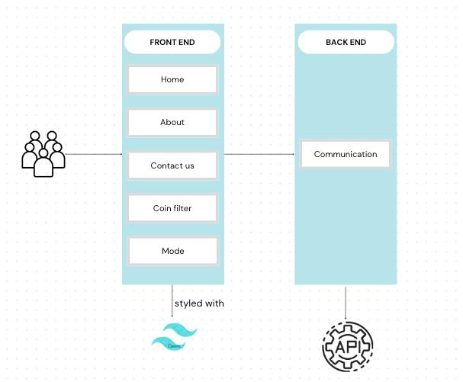

USE CASE:
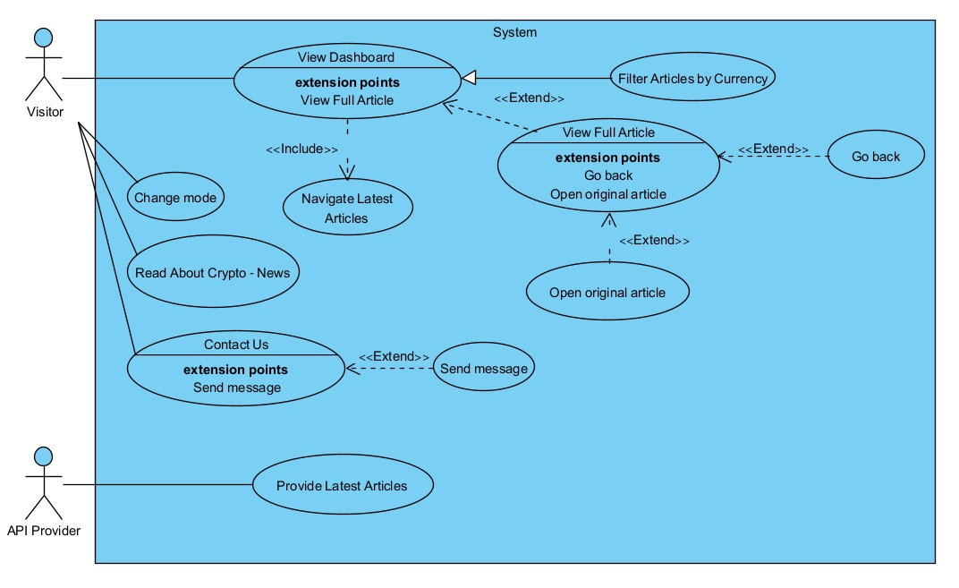

Package Diagram:

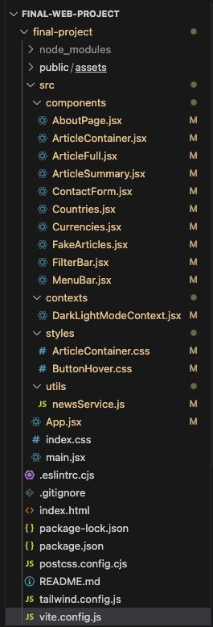
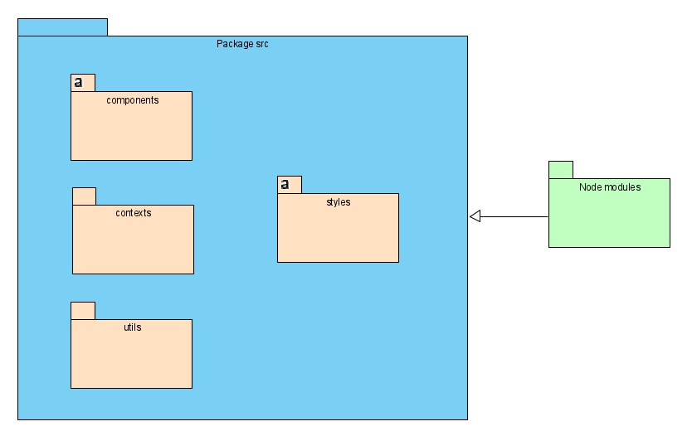

Programmer file:
- Project main function:
- handleSubmit (ContactForm.jsx)- The handleSubmit function handles the form submission event by preventing the default form action, validating the form data, and sending an email using the emailjs service if the data is valid. It updates the state and logs appropriate messages to the console based on the success or failure of the email sending process.
- useEffect (App.jsx) - hook dynamically updates the page title based on the current route and state. This ensures that the title reflects the content being viewed, such as displaying a specific cryptocurrency news title on the home page, or a general title for other pages like "Crypto - News." This approach enhances user experience and accessibility.
- fetchArticlesByCurrencies (newsService.js) -The function fetches articles from the GNews API based on an array of selected cryptocurrencies. It formats the array of currencies into a query string, makes an HTTP GET request using axios, and then processes the response data to fit the application's requirements. If successful, it returns an array of formatted articles; otherwise, it logs the error and returns an empty array.
- formatCurrencies (newsService.js) function converts an array or string of selected cryptocurrencies into a query string formatted for the GNews API. This ensures that the query correctly filters news articles related to the specified cryptocurrencies and topics, enhancing the relevance of fetched data.
- The first useEffect (ArticleContainet.jsx) in the ArticleContainer component makes an asynchronous data fetch from the API using the newsService whenever the currenciesToShow prop changes. It defines an asynchronous function getArticles to fetch and set the articles based on the selected currencies, ensuring the displayed articles are updated accordingly.
- The second useEffect (ArticleContainet.jsx) in the ArticleContainer component handles and plays the carousel of the articles on the home page. It starts the automatic sliding of articles when the articles are loaded and cleans up the interval on component unmount. This ensures the carousel continuously rotates through the articles, providing a dynamic display.
- formatArticles (newsService.js) function restructures articles fetched from the GNews API into a standardized format required by the application. This includes extracting and formatting key information such as title, summary, content, image, publication date and time, associated currency, source, and URL, ensuring consistency and ease of display within the app.
B.
- We used an API called GNEWS: https://gnews.io/api/v4/search
To display real-time articles, we connected to an API called G-News. The G-News API offers numerous advantages, making it a successful choice for news applications. It provides comprehensive and diverse access to real-time news articles from a wide range of sources, including major news outlets and blogs. The API supports customizable queries, allowing filtering and sorting by various criteria such as keywords and language, and provides rich metadata for each article.
- React: A JavaScript library for building user interfaces, particularly single-page applications where data can change without requiring a page reload.
- ReactDOM: Provides DOM-specific methods that can be used at the top level of the application to enable efficient rendering of React components.
- React Router: A collection of navigational components that compose declaratively with the application, allowing for dynamic routing in a React application.
- Axios is a promise-based HTTP client for JavaScript, used to make HTTP requests from the browser or Node.js. It provides a simple and easy-to-use API for handling asynchronous requests and responses.
- EmailJS is a service that allows you to send emails directly from JavaScript applications without a server. It is useful for integrating contact forms and other email-related functionalities into web applications.
User file:
The Crypto News application is a one-page web app designed to provide users with the latest news in the cryptocurrency world. The homepage features a dynamic and visually engaging layout, focusing on ease of navigation and readability.

Home Page
Header Section*: Logo, Navigation Links (Home, About, Contact Us), Theme Toggle**.
Cryptocurrency Filter Bar*: A horizontal bar with buttons for various cryptocurrencies.
Main Content Area: News Carousel that contains news card. Each card in the carousel includes Image, Headline, Details, Source, Read Full Article Button.
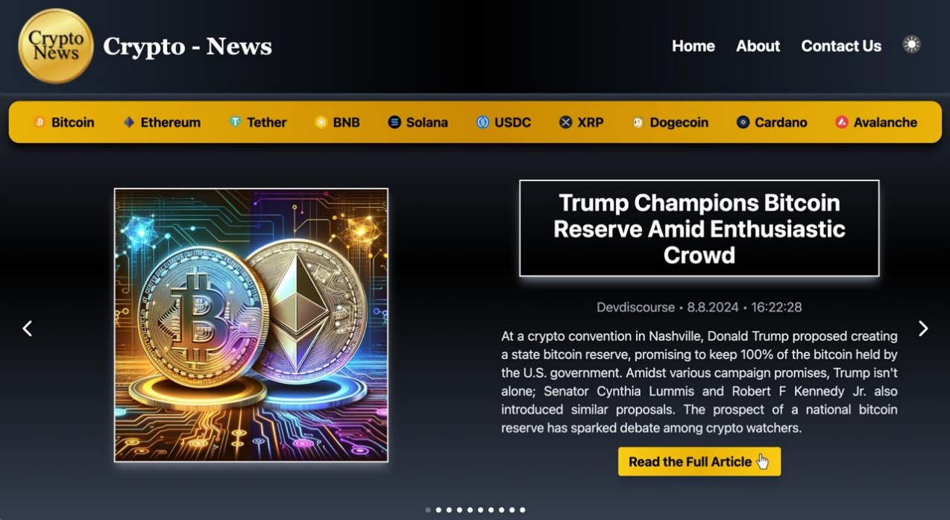

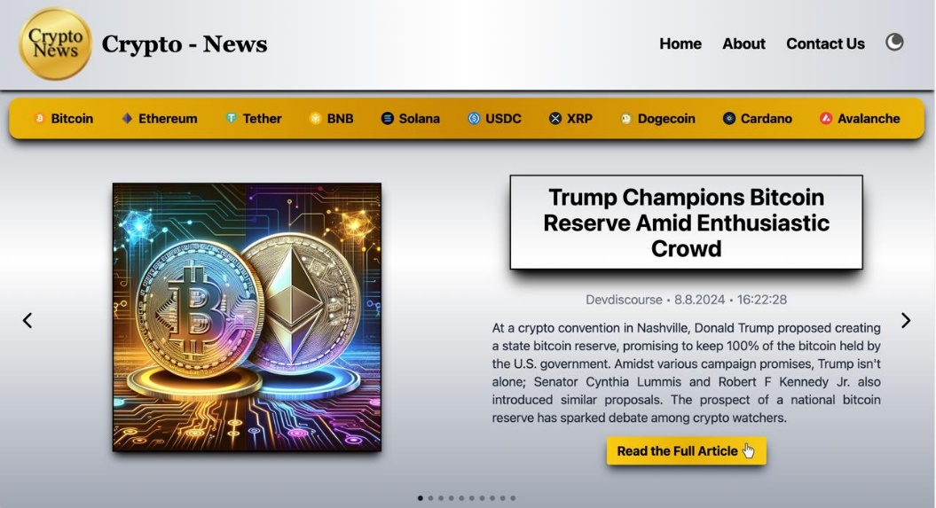

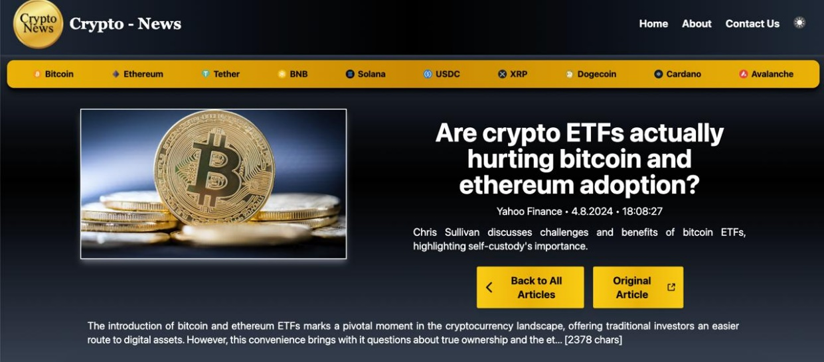
BY clicking the "Read the full Articles" button
Full Article Page

Clicking on any cryptocurrency button filters the news articles displayed in the carousel show relevant news for that specific cryptocurrency.
For example Ethereum Page
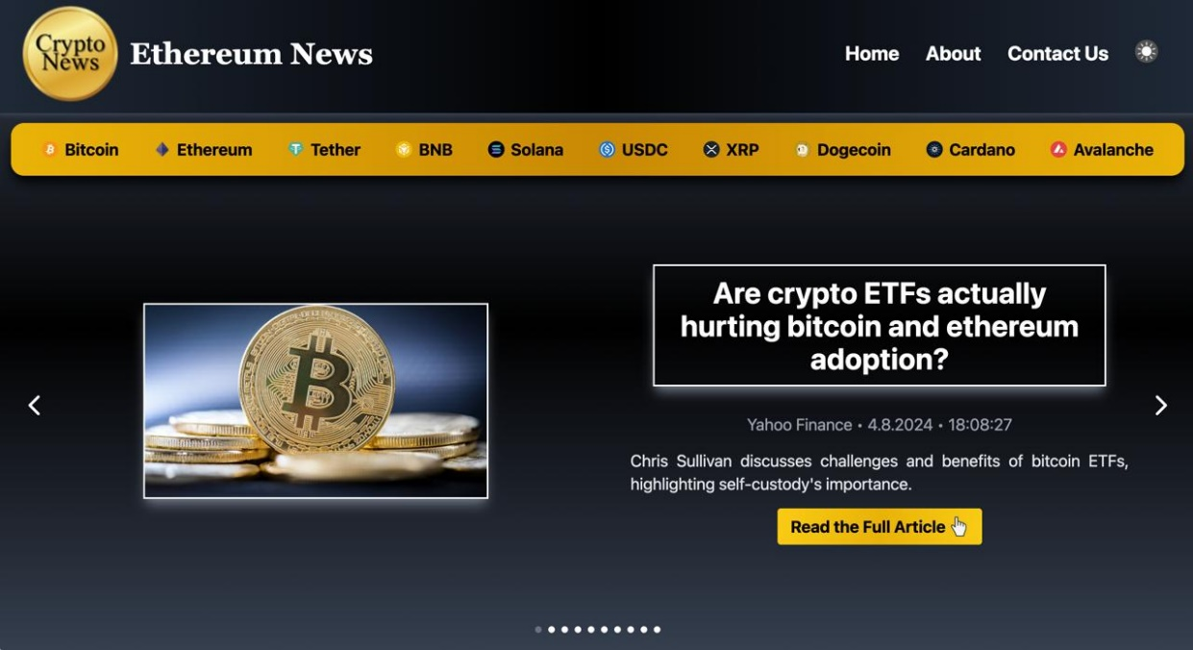

By clicking on the "About" button on the Header section the About page will open.

About Page
The About page of the Crypto News application serves as a comprehensive resource for users to learn more about the platform, its mission, and the team behind it. It emphasizes transparency, accessibility, and clarity, ensuring that users have a positive and informed experience.
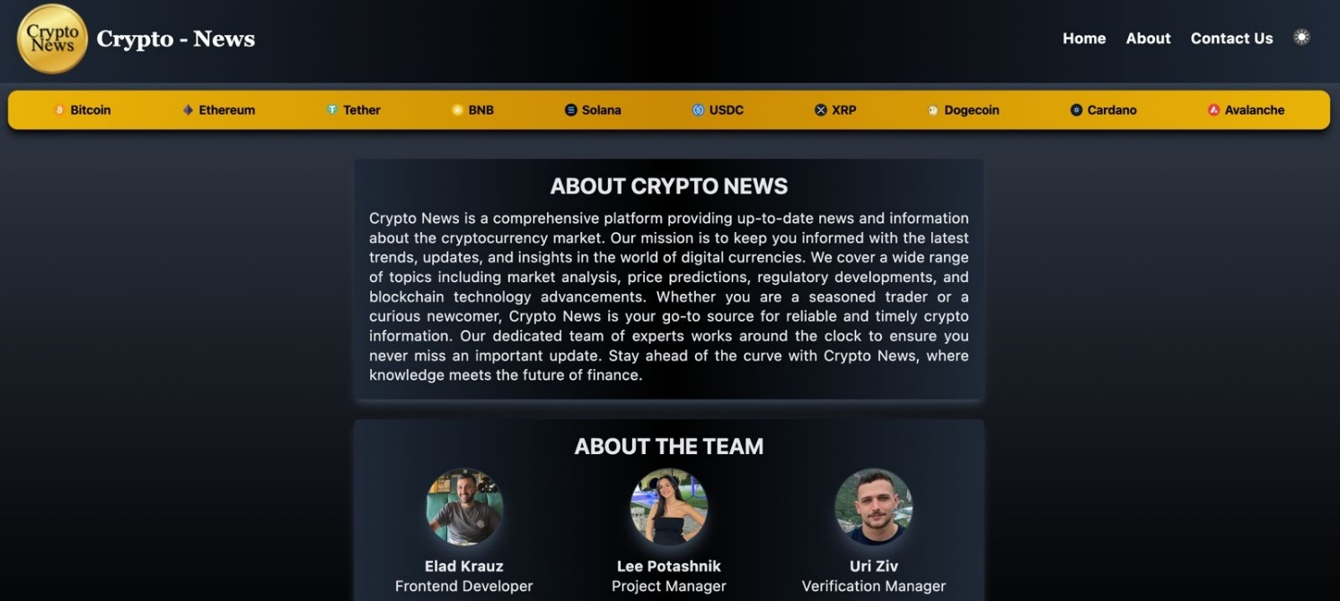

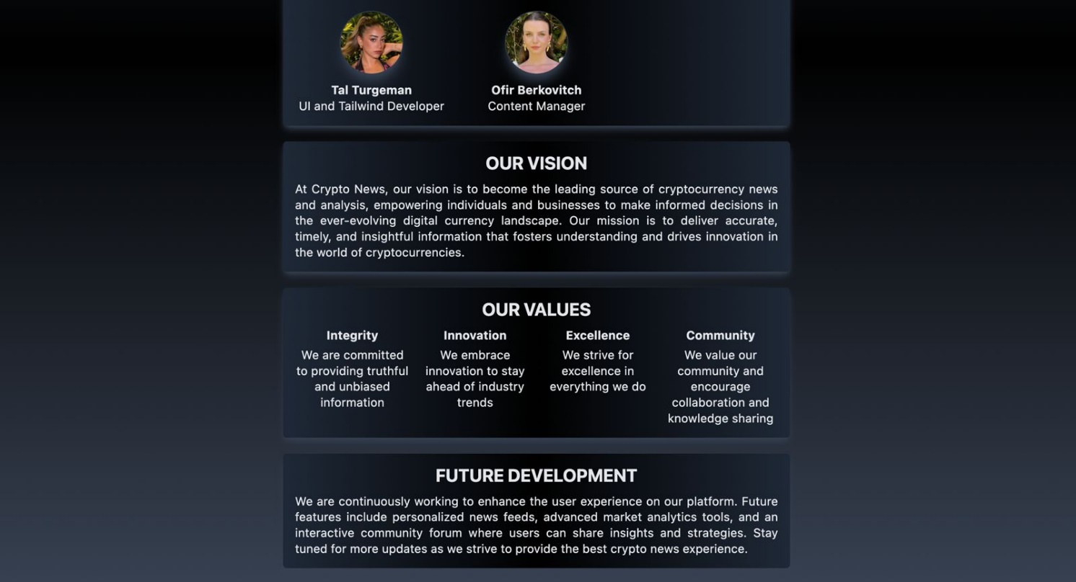

By clicking on the "Contact Us" button on the Header section the Contact Us page will open.

Contact Us Page
The Contact Us page of the Crypto News application provides a user-friendly and accessible way for users to communicate with the platform's support team. The form is designed with clarity, accessibility, and consistency in mind, ensuring a seamless user experience.
The page invites users to share their thoughts and feedback, fostering a sense of community and engagement with the platform.

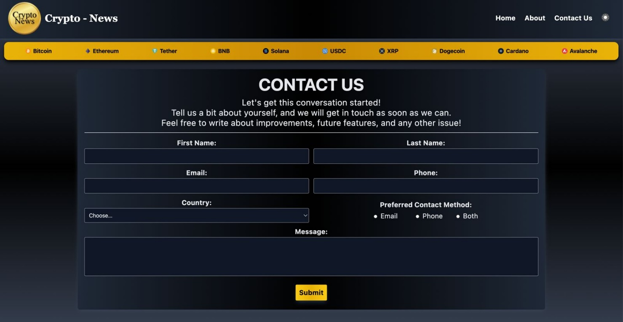

This page includes real-time validation to ensure that all necessary fields are filled out correctly before submission.
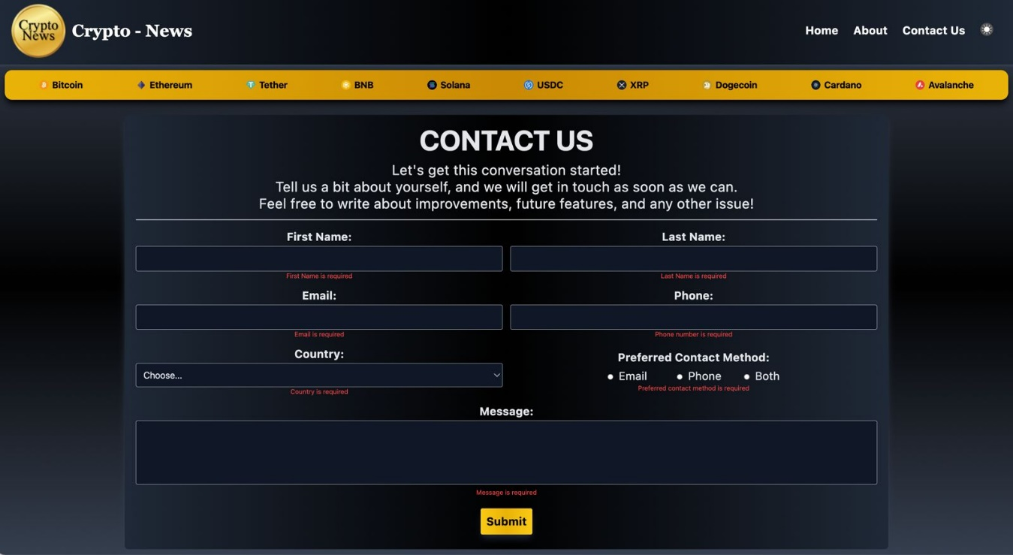

After successful validation of the details and clicking on the "Submit" button.

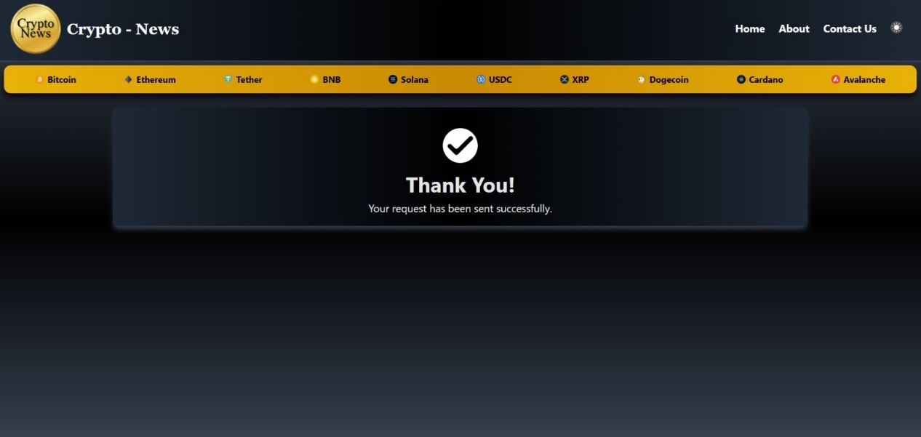

The application includes an error handling feature that is designed to inform users when the news feed is temporarily unavailable.
This ensures that users are aware of temporary issues and can easily attempt to reload the page for updated information.

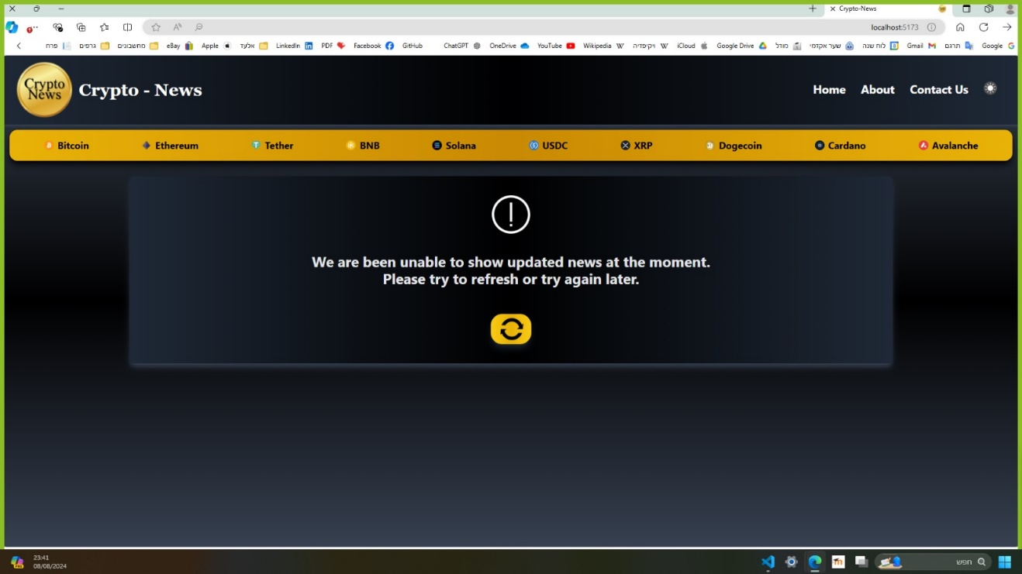

* The "Header Section" and "Cryptocurrency Filter Bar" remain at the top of the screen throughout the site.
** Theme toggle button appears at the "Header Section" and can be changed at any time throughout the site.

